Sample for RE  
SUMMER 2021  
Subject: WED201c  
Duration: 120 minutes

**Objectives:**

1. Create css files and link it to the html files.
2. Create a javascript file and link it to the html file.
3. Use html tags to create a web page.

**Background:**

In this practice exam, you are given a folder “**Resource**”. You are going to use page “index.html” to finish the exam.

**Before styling index.html page**

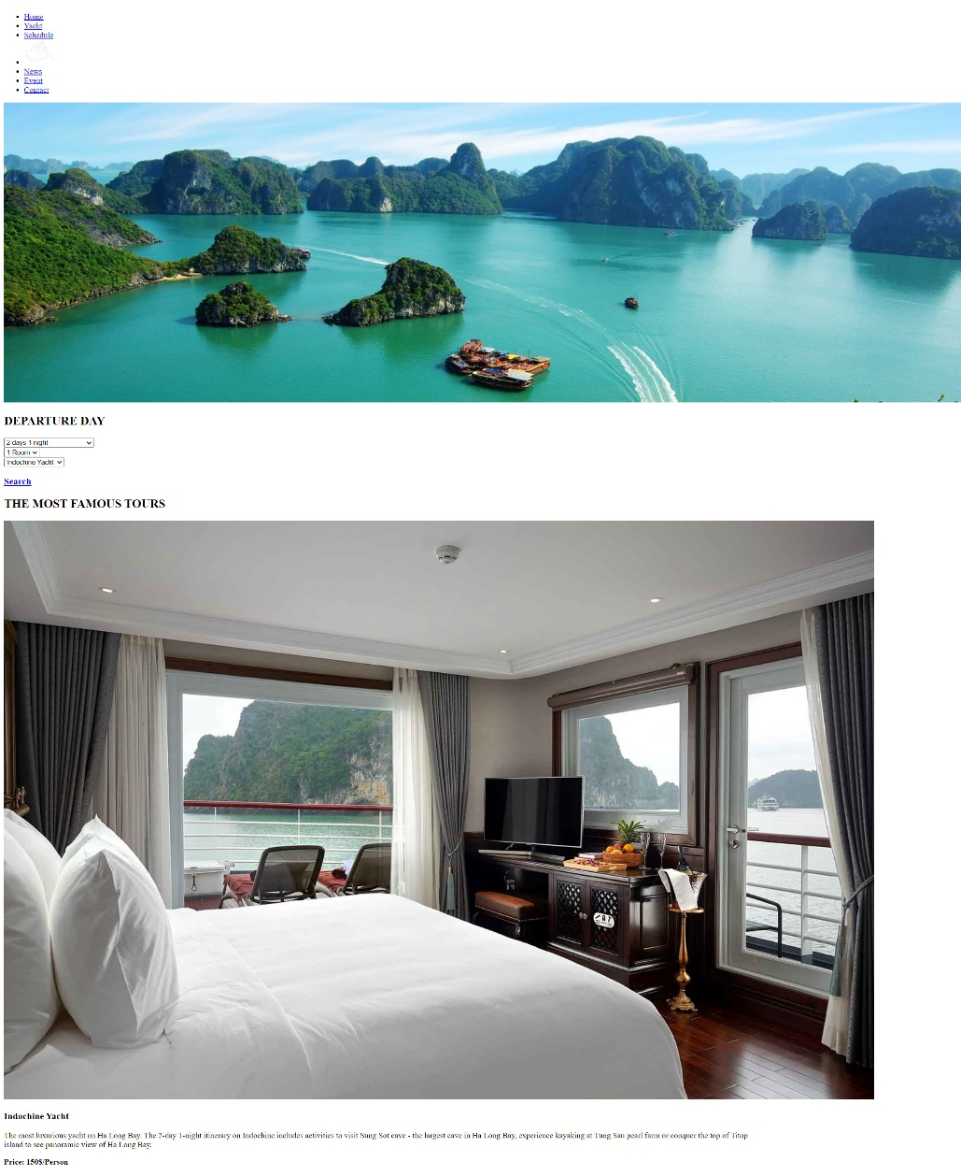

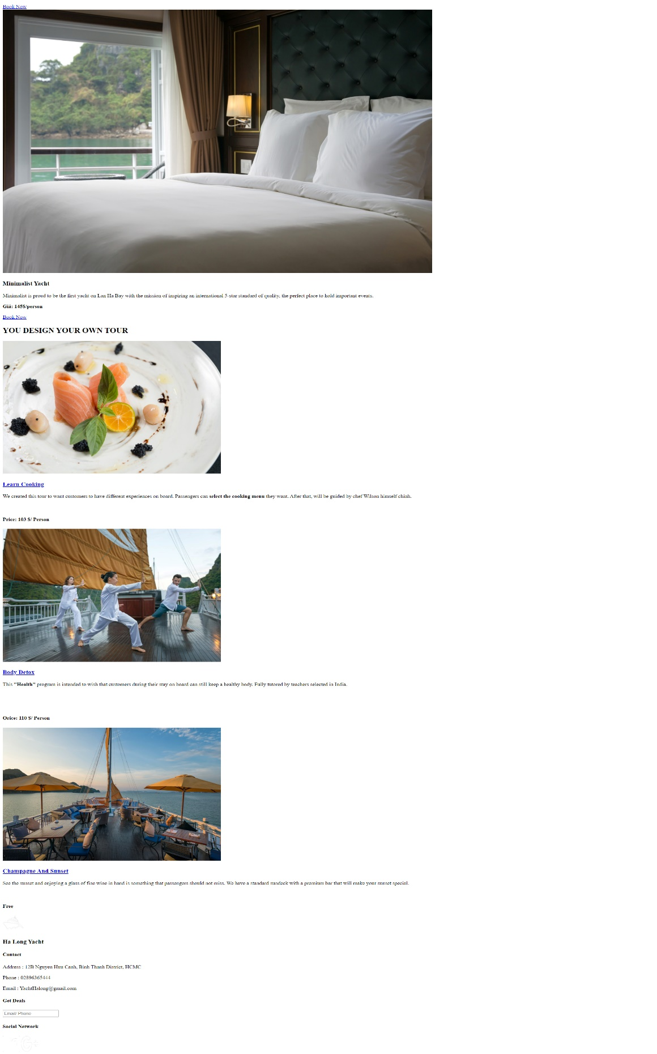

**After styling index.html page**

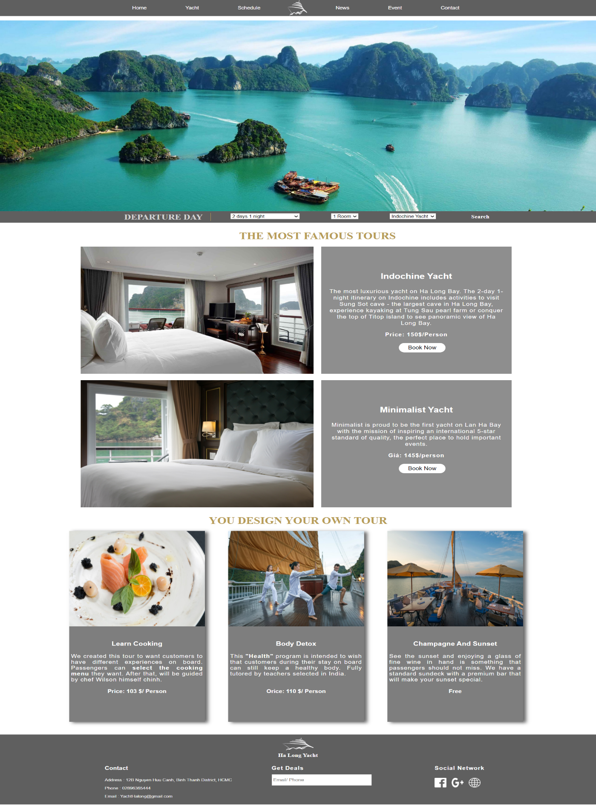

**Required:**

1. Create a file with the name **contact.html** and save it to **Resourse folder** as shown below:

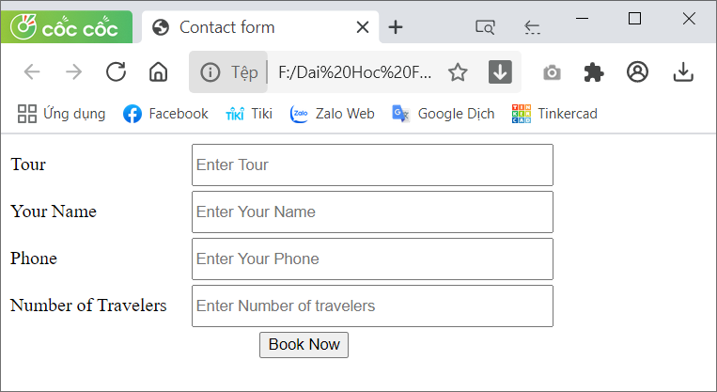

1. Create a file called **styleindex.css** to format the index.html page and save it to the **Resource folder**.
2. Create a file called **stylecontact.css** to format the contact.html page and save it to the **Resource folder**.
3. Create a file called “**mycode.js**” and save it to the **Resource folder.** You must link this file to the contact.html page.

**Evaluation**

1. **Add html tags [2.5 marks]**

* Use tags div, label, input to create contact.html page[1.5 points].
* Create a link for the contact menu to open the contact.html page [0.5 points].
* Embed css and js files in their respective pages [0.5 points].

1. **CSS [ 6 marks]**

* Use css box-shadow to create shadows on divs [1 points].
* Use margin and padding to create the right spacing for the content [1 points].
* Use width, height to format images as shown above [1 points].
* Use color, list-style-type,background-color… to format the content [1 points].
* Use border-radius and text-align to round for the content [1 points].
* Use width, height, inline-block… to format the content of contact.html page [1 points].

1. **Javascript [1.5 marks]**

* In file mycode.js, you must **create function with name CheckData()**  base on description:
* When the user clicks on the Book Now button, check the following information: Tour, Your Name, Phone and Number of Travelers are not empty. If the user enters missing information, the corresponding message dialog box is displayed [1 points].
* If the user fills in the information, the message dialog box with the content "Welcome to book a tour" is displayed [0.5 points].
* Example:

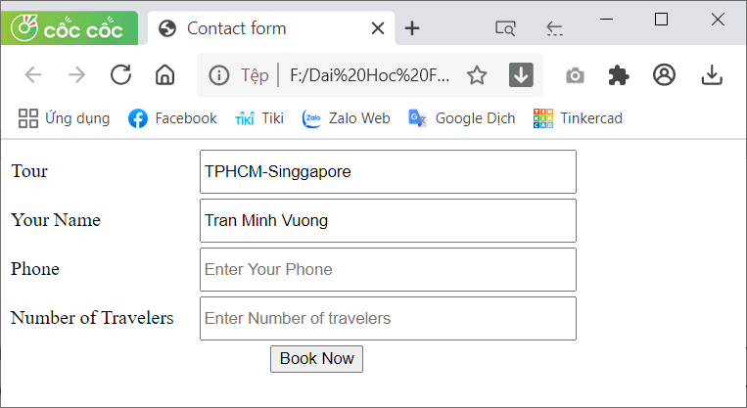

**The end**

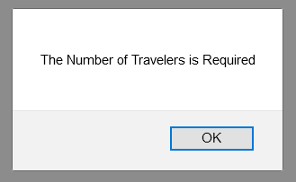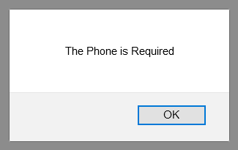

**--The End--**